436MP

JERZEES

Jersey Knit With Pocket

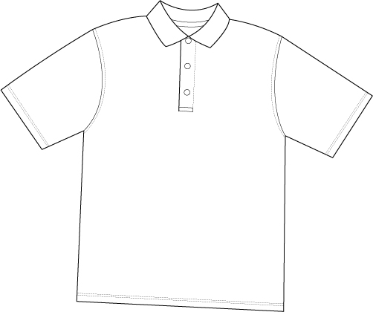

Descriptions
*50/50 poly cotton, 5.6 ounce
*Welt collar
*2 Pearlized button placket
*Double needle sleeve and bottom hem
*Embroidery & screenprinting okay

Finished Garment Measurements

Size | S | M | L | XL | 2XL | 3XL | 4XL
Width 1” under armhole | 19 | 21 | 23 | 25 | 27 | 29 | 30
Length from shoulder point | 29 | 30 | 31 | 32 | 33 | 34 | 35
Sleeve Length from CB | 19 | 20 | 21 | 22 | 23 | 24 | 25
Shoulder Width | 17 | 19 | 20 ½ | 22 | 23 ½ | 25 | 26 ½

